APE/7549/2009 Date: <To>

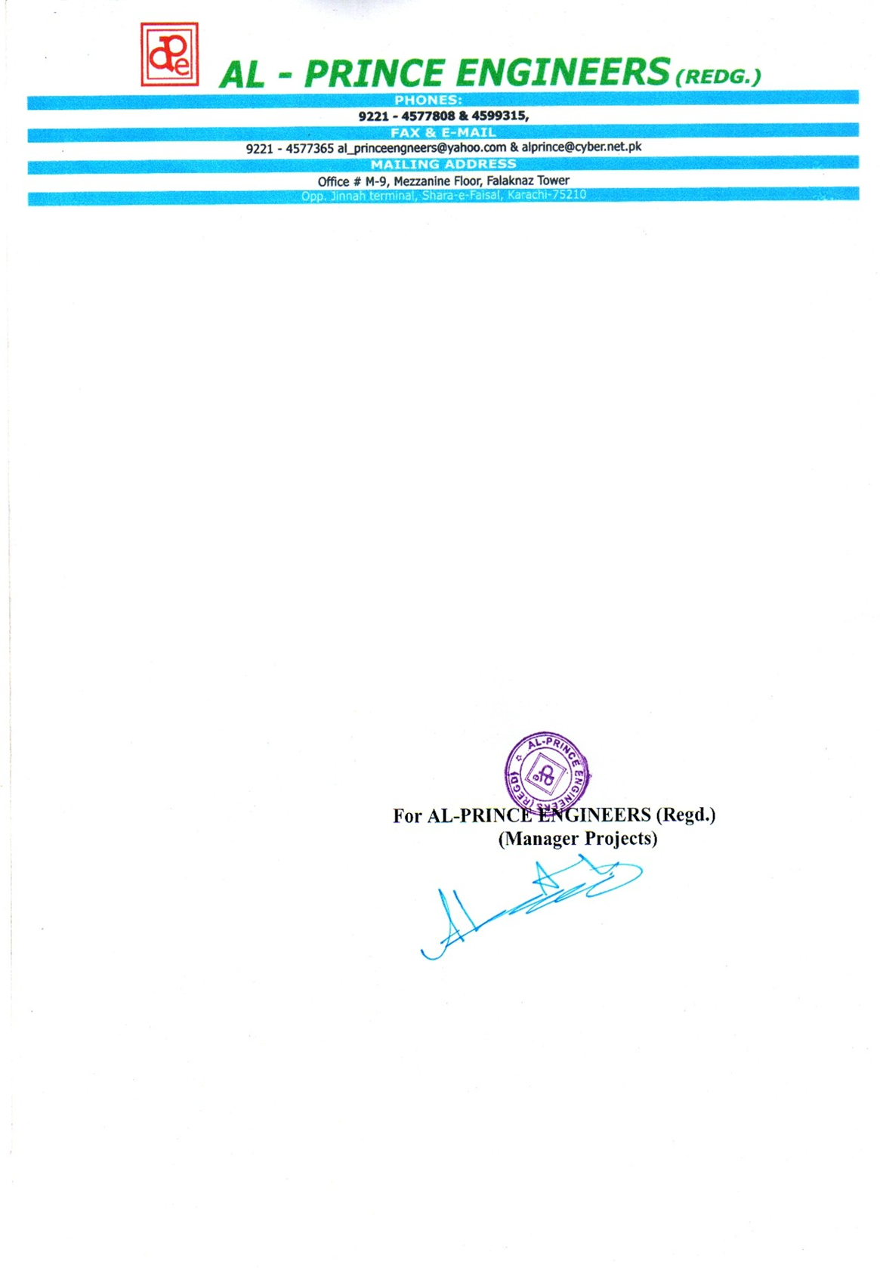

**TO WHOM IT MAY CONCERN**

This is to certify that Mr. <name> S/o <fname> has worked in our company as “<Designation>’’ With effect from <from> to <to> at Lucky Cement Factory Nooriabad.

During this period, we found him very regular, intelligent & good moral character, he is dutiful & have served up to our entire satisfaction.

We wish him all the success for his future.